**BofM final study guide**

**Lecture 12 (2 Nephi 11, 17, 20, 25)**

**Things I Hope You Know/Understand:**

The meaning of Isaiah’s name

Jehovah saves/is Salvation

Why are the teachings of Isaiah quoted so often in the Book of Mormon

He wrote sacred things, he prophesied of Jesus Christ, persuades the people to believe in Christ, proved the coming of Christ

Isaiah’s primary doctrinal focus in his writing

The Atonement of Christ, Jesus is the Christ

How to read 2 Nephi 17 and 20 exegetically (remember “Context A” and “Context B”)

“Country music”

Context A: the context of the time of Ahaz figuring out what to do with Assyria and Syria/Northern Kingdom

Context B: the context of the Birth of Jesus (a God with us)

Be able to identify the key places and people from our “Isaiah Map”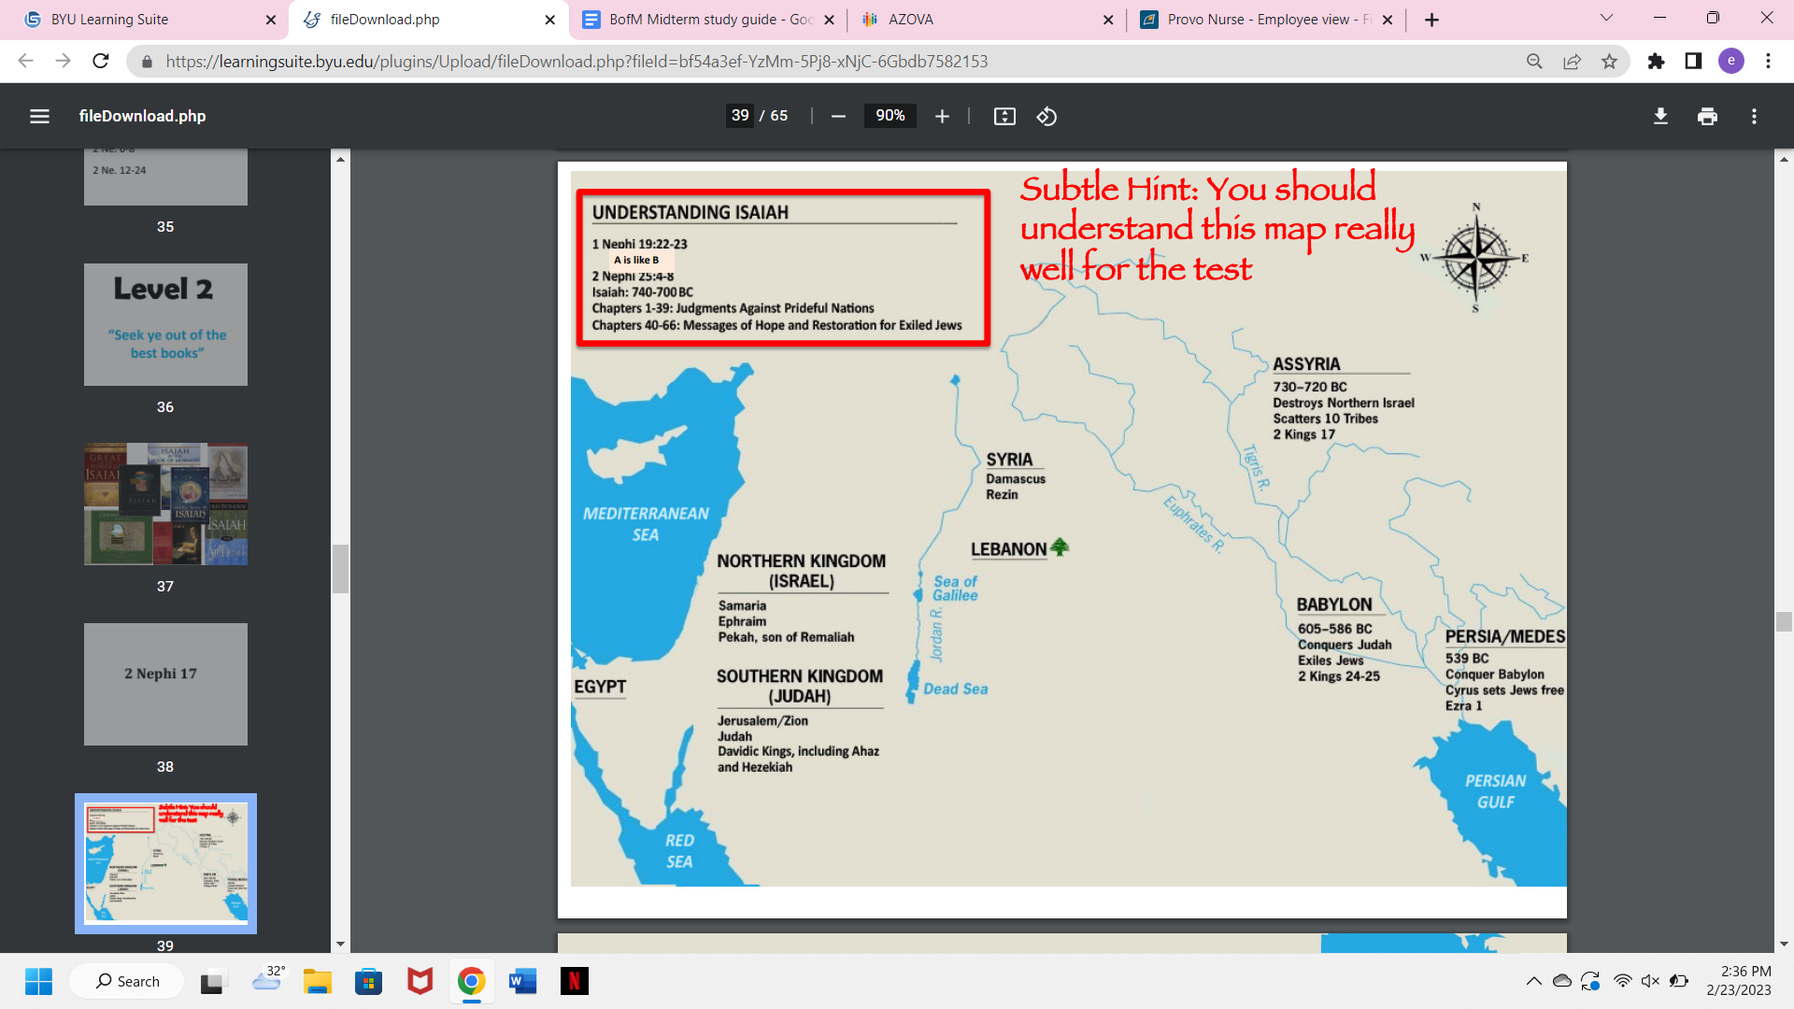

**\*See slides 39-43\***

**Assyria** = military powerhouse of the day, attacked Northern Israel, 10 tribes were lost, in 722 BC

**Babylon** attacked **Southern** Kingdom Judah (which contained **Jerusalem**) and took Jews captive into Babylon, in 587/6 BC

**Persia**/**Medes** attacked **Babylon** and freed the Jews held captive there and restored them to Jerusalem, in 539/8 BC

Resources available to enhance your study of the Isaiah chapters

Use the footnotes in the Bible to help as you study Isaiah in the Book of Mormon

“Seek out of the best books”

Examples of how to read Isaiah WITH Nephi and Jacob

Read the Book of Mormon with Nephi/Jacob/Jesus.

5 Tips for understanding Jacob 5

1. Read the chapters before and after (4&6)
2. Understand the symbolism
3. Begin with an overview
4. Pay particular attention to the fruit
5. Study Jacob's commentary on the allegory

What Elder Holland suggests as the “wiser purpose” for Nephi writing the small plates (supplementary reading)

D&C 10:45, "Behold, there are many things engraven upon the [small] plates of Nephi which do throw greater views upon my gospel” (The Lord instructs Joseph of translating process from the small plates into the translation of the abridged large plates

**\*We got back more than we lost from the 116 pages\***

Assyrians are moving toward Jerusalem, treaty is broken

**Lecture 13: 2 Nephi 25, 31-33 (Recorded lecture)**

**Things I Hope You Know/Understand**

What Nephi teaches about the doctrine of grace

It will save us, cleanse us, **transform** us **Alma 24:11**

**Become new creatures in Christ**, looking to Christ and relying on Him (Moses and the serpent)

Where the bible references the phrase “doctrine of Christ” and what those passages say about it

MARK SCRIPTURES: 2 Nephi 31:2 and 1 Nephi 15:14

**Hebrews 6:1-2**, captures repentance, faith, baptism, laying on of hands

Draw upon imagery of ascent (**Hebrews 7**)

Yom Kippur (**Hebrews 9 and 10**), remission of sins

Christ becomes veil (priest represents), **brings us to God**

The purpose of Yom Kippur (and the important role of the high priest)

1 person can enter into holy of holies, presence of God, the high priest

Temple captures image of divine ascent: moonstones, star stones, sun stones

We ascend and meet him in Holy Place

Similar with tabernacle, make it into presence of God on behalf of people, high priest

Altar of sacrifice (faith and repentance, baptism/cleaning)→ Altar of incense → Presence of God (steps of plan of salvation or 3 kingdoms of glory)

Feast upon the words of Christ, be clean, pray to the Father

The symbolic representation of the tabernacle in 2 Ne. 31-32

Tabernacle = progression westward back into the presence of God

Nephi delights in plainess, but what plane are you on? (he speaketh unto men according to their language, unto their understanding)

**2 Nephi 31:4,7,9-11** (baptism)

Christ sets the example of how we ascend, our path back into presence of God

Be able to differentiate between Core Doctrine, Eternal Doctrine, Supporting Doctrine, Policy Doctrine, and Esoteric Doctrine (Supplementary Reading)

**Core** - unchanging truths of salvation

**Supportive**- elaborative, descriptive, timely teachings, expanding on core doctrine

**Policy**- timely statements related to application of supportive or core doctrine

**Esoteric**- unknown or only partially revealed

Ex: Baptism → baptism for the dead → proxy baptisms in the temple, keeping record of them → how proxy baptisms will be accepted

**Lecture #14: Jacob 7 (Recorded lecture)**

**Things I Hope You Know/Understand**

Compare and contrast Sherem and Nehor (Methods, message, etc)

*Note: We will talk about Nehor later in the semester so just focus on Sherem for now*

Development of Hebrew evolved into many Native American languages, seems impossible, not a claim Jacob 7 makes: A man came among the people of Nephi (**Jacob 7:1**), no need to make square peg fit into round hole

**SHEREM**: there is no Christ, perversion to convert law of Moses into worship of Christ, denies power of Holy Ghost

* METHODS: Flattery, power of speech, diligence, targets the faithful, well-educated, contentious, sign-seeker, wrests the scriptures
* Modern examples: imposing Christ into the text of the Old Testament

What Jacob teaches on how to make faith unshakeable

**MARK SCRIPTURES: Jacob 7:5**, truly had seen angels, heard the voice of the Lord

Jacob had had many revelations, had own experiences with the Lord (Moses 1:13)

A person with an experience is never at the mercy of a person with an opinion

Jacob’s method and message in trying to teach Sherem

MARK SCRIPTURES 7:10-12, Jacob 7:8 The Lord God poured in His spirit into my soul

1. Scriptures
2. Prophets
3. Power of the Holy Ghost

Compare and contrast the outcome of Sherem’s preaching vs Nehor’s preaching

*Note: We will talk about Nehor later in the semester so just focus on Sherem for now*

**SHEREM**: teachings died off and people returned to reading the scriptures

* Jacob 7:23, searched the scriptures
* Believe and Sherem is no longer an influence in the lives of the people

**NEHOR**: teachings persisted longer than him because they were pleasing

**Lecture #15: Jacob 4-6**

**Things I want you to know**

The 3 approaches to Jacob 5 discussed in class

1. **Read allegory WITH Jacob (chapters 4-6, chapters give context)**

The mark is Christ - Elder Maxwell- MARK SCRIPTURES Jacob 4:14

What was the question that drew out the answer? How is it possible that these people in their flaws ever come unto the fold?

* Jacob 4:18, Jacob 5 answers

1. **Understand symbolism (not for the final)**
2. **Begin with an overview**

* As a history of the house of Israel (**1**) - MARK SCRIPTURES (see slides)
* The Lord and His servant (**2**) - MARK SCRIPTURES (see slides)
* The 4 visits in the allegory (**3**) - MARK SCRIPTURES (see slides)

The symbolism in the Allegory

Graft=come to knowledge of the Messiah, their Lord and Redeemer

**See slide #20**

Be familiar with the doctrinal focus in Jacob 4 (and specifically how it sets up Jacob 5)

How is it possible the Jews, after having rejected Christ, can ever build upon Him?

* Gospel will go to gentiles (they'll be **grafted** in, come to knowledge of Christ) who will then take it to the Jews

How is it possible that we, after having rejected Christ, can ever build upon Him?

Jacob 4: 17, Jacob 5 is the answer

Which Book of Mormon author first compares the house of Israel to an olive tree

Who is the first person who introduces the allegory of the olive tree? **LEHI**

What lessons Jacob emphasized from the Allegory (hint: Pay attention to the language he uses in Jacob 6)

Pronouns -- "My vineyard", mine own self, mine own purpose

The last time (MARK SCRIPTURES 6:2, 5:62-64, 5:70-71)

THE 4 VISITS:

1. Before the time of Christ- Jacob 5:3-14 **GRAFT** (verse 8)

* Grafted in: 1 Nephi 10:12-14, coming to the knowledge of their Lord and Savior
* If Gentiles repent, they can come unto Christ, grafted into the covenant, will take it to the Jews (take worldwide)
* A long time passed away (Jacob 5:15)

1. The time of Christ - 5:15-28

* *Christ labored among the Jews first (tame olive tree)
* But also among some nonIsraelites (wild olive tree)
* A long time (5:29)

1. The great apostasy - Jacob 5:29-49
2. The gathering of Israel - Jacob 5:50-76

* A long time, possibly the Millenium

1. **Study Jacob’s commentary on the allegory**

**Lecture #16: Enos, Jarom, Omni, Words of Mormon**

**\*Nothing about this on the study guide\***

**Lecture #17: Mosiah 1-5; Becoming the Children of Christ**

**Things I Hope You Know/Understand**

What were the two stated purposes of King Benjamin gathering his people together?

The man: Righteous and respected king, servant-leadership (MARK SCRIPTURES, slide #16&17)

Mosiah 1: 10-11

The **multitude**:

The **moment**: feast of tabernacles (see slide #31 & 33)

The **message**: Mosiah 2:3

1. Transfer the power
2. Give them a new name (take upon them the name of Christ)

What were the pieces of evidence which led some scholars to believe there is a possibility that Mosiah 1 may not have been the original first chapter of the Book of Mosiah (they believe it may have been Mosiah3)?

Lack of book intro (no synopsis)

Begins mid-story

Book normally named for whoever was the leader/record keeper

Printer’s manuscript calls this Mosiah 3

What Israelite feast might this event have been connected to?

Feast of tabernacles (see slide #31 & 33)

What are some examples of temple symbolism in these chapters?

See slide #33

What unique insights into the Atonement of Jesus Christ does King Benjamin’s provide us? (See slide #40)

Great shall be his anguish (thirst, fatigue, temptation, blood from every pore)

Becoming as a child

Blood atones for those who haven’t had a chance to hear the word

Put off the natural man, become a saint, forgiven by the law but also sanctified

What is the connection we discussed between receiving and retaining a remission of our sins?

Mosiah 2:4

*Serve*Are we not all beggars? We all rely on the same God

Thou shalt love thy neighbor as thyself, hen ye are in the service of your fellow beings ye are in the service of your God

**Lecture #18: Mosiah 11-16**

**Things I Hope You Know/Understand**

Who was Abinadi’s initial audience?

Mosiah chapter 11: 22, 27-28, 12:1, 4: The people of King Noah (“my people”)

Shifts to King Noah and his priests

What is the difference between intertextuality and intratextuality?

INTERTEXTUALITY- The relationship between texts, especially literary ones

* BofM drawing upon Bible (priests questioning Abinadi)
* Isaiah 52:7-10, (Isaiah in the BoM)

INTERTEXTUALITY- Within a single text

Who are some of the individuals in the Book of Mormon who quote Abinadi?

Alma, Amulek, Mormon, King Benjamin (**see slides #11-15**)

According to Abinadi, what were some of the purposes of the law of Moses?

Perform ordinances, to observe strictly

Mosiah 12:27-33: teaches not to set your hearts upon riches, commit whoredomes and spend time with harlots, and cause those around you to commit sin, asks if salvation comes by the law of Moses.

What were the two questions Abinadi is focusing on in his sermon?

1. What meaneth these words of Isaiah? - Mosiah 12:20
2. Does salvation come by the law of Moses? - Mosiah 12:31-37

* Mormon references Moses, making that comparison

Why does Abinadi seem to quote Isaiah 53?

The “suffering servant”, Jesus took the flesh.

God must come down to atone. Salvation doesn't come by law alone.

14:3-9, 11 “despised, rejected, esteemed him not, sorrows, wounded, bruised… etc

What teaching led to Abinadi’s death sentence?

“God himself” would come down, and be a man and suffer these things

**Mosiah 13:27-35**

Christ isn’t a strong political leader who would save and free the people

**Mosiah 16:8**

What was Abinadi likely teaching when he was referring to Jesus as the Father?

The son = the mortal part of Him (subjected to the flesh)

The father = immortal, saw spirit triumph over death

Which of the two “lamb” metaphors from Isaiah does Abinadi choose to emphasize and why might he have chosen it over the other?

Abinadi chooses to emphasize Christ was "as a sheep before her shearers" rather than a “lamb to the slaughter”

* Christ was submissive, but he rose again
* We also have those two sides, and should submit the flesh to the spirit

**Lecture #19: Mosiah 27-Alma 1**

**Things I Hope You Know/Understand**

How does Alma the younger’s story act as an object lesson to the stated purposes from the title page of the Book of Mormon

Ultimate “pivot” story, a movement from pain to the joy of salvation through Alma's repentance

“To show how merciful the Lord hath been and that they are not cast off forever”

Intratextuality in Alma 36

Mosiah 27:23-30 and Alma 36:12-24 - he wanted to see God

How Alma describes his conversion experience

But I was racked with eternal torment, for my soul was harrowed up to the greatest degree and racked with all my sins **(Alma 36:12-24)**

* **Rack**: To torture; to stretch or strain on the rack or wheel; as, to rack a criminal or suspected person, to extort a confession of his guilt, or compel him to betray his accomplices.
* To torment; to torture; to affect with extreme pain or anguish; as racked with deep despair

My soul did long to be there, longing for home

**Lecture #20: Alma 1-5**

**Things I Hope You Know/Understand**

Possible definitions of the term “anti”

1. In opposition to
2. In the place of, in replacement of

Compare and contrast Sherem and Nehor (Methods, message, etc)

Sherem = there is no Christ

Nehor = there is a Christ, so do whatever you want, God will save everyone, so don’t worry about consequences

* Sincere, prideful, established a church, contention, priestcraft (see slide #36-40)
* Message lives on after his death because it is more desirable **Alma 1:3-4**

Based on our class discussion, what do we mean by “resilient faith”

Comfort zone of faith → disruption of our belief (questioning), destabilizes foundation → 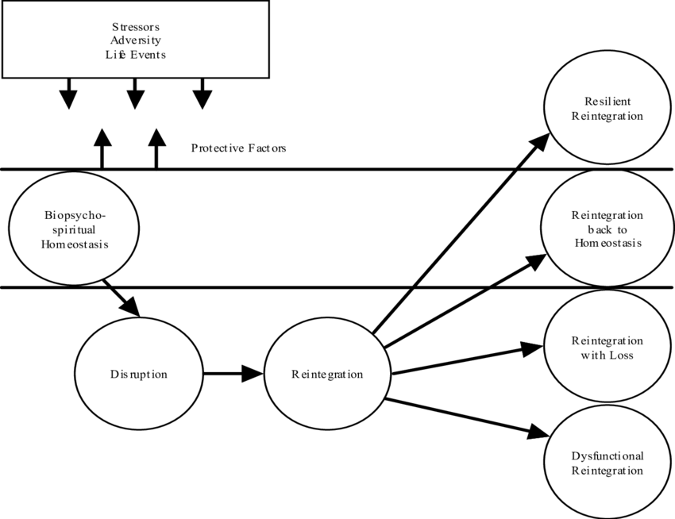

* Reintegrate with anger/frustration towards others, God
* Reintegrate and bounce back, move on
* Reintegrate with faith stronger than before

**Lecture #21: Alma 5-7**

**Things I Hope You Know/Understand**

Why Alma chose to give up the judgment seat

Wanted to go forth "among the people of Nephi ... to stir them up in remembrance of their duty, ... bearing down in pure testimony against them" (become a missionary) (Alma 4:19)

A basic structure of Alma’s sermon in Alma 5 SLIDE #29

Alma 5:3-13- Remember how merciful the Lord hath been

Alma 5:14- Have you experienced this same mighty change?

Alma 5:15-25- Thoughts on looking forward with an eye of faith

Alma 5:26- Do you still feel to sing the song of redeeming love?

Alma 5:27-30- Are you presently keeping your covenants?

Alma 5:31-35- Repent and come unto Christ

Alma 5:36-42- Warning if you don’t choose to repent

Alma 5:43-48- I know of these things myself

Alma 5:49-51- Repent and be born again

Alma 5:52-56- Warning if you don’t choose to repent

Alma 5:57-61- Promises if you choose to repent

Alma 5:62- Final Invitation- repent, come and be baptized

The primary theme Alma develops at the beginning of his sermon

Only through Christ can we be changed, the Lord delivers His people

The significance of the waters of Mormon

3 Nephi 5:12

* Sacred to those who came to its waters because of the experiences that were had
* Parallel to Book of MORMON, becomes divinely sacred to those millions of people who come “to the knowledge of their Redeemer”

A possible interpretation of “engrave” and also “born again”

Alma 5:14,19,26 Repent and be born again

What does it mean to “receive his image” or have “his image engraven upon our countenances”?

ENGRAVE = Hebrew for ordinance

Born again = born from above (Greek), comes by the Spirit of God through ordinances

The question Alma asks those in Zarahemla who felt that had already experienced a change of heart

Can ye feel so now?

The distinction between how Alma addresses those who belong to the church and those who do not?

Members- speaks by **command**

Nonmembers- speaks only by invitation to repent and be baptized

The metaphors Alma uses to teach about change through the Atonement of Christ

Alma 5:7- Changed heart, awakened out of a deep sleep, soul illuminated in

midst of darkness

Alma 5:9- Bands broken, chains loosed, soul expanded, sing redeeming love

Alma 5:14, 19- Spiritually born of God, received God’s image in countenance, mighty change of heart

Mosiah 27:25-29- Born again/of God, redeemed, becoming God’s sons and daughters,

new creatures, snatched out of everlasting burning, redeemed from bitterness and bonds, from darkest abyss to marvelous light, racked with torment but now snatched, soul pained no more

Compare and contrast Alma’s message to the saints in Zarahemla with those in Gideon

Zarehemla and Gideon were both current church members, but Zarehemla was suffering from pride, whereas Gideon was full of faith

* Ammonihah was an apostate city. Satan had his grip

He taught Zarahemla pure testimony and the atonement for sinners through reflection questions, where he used narrative and invitation to teach pure testimony of Christ and his atonement for saints

* Alma taught the people and Ammonihah through helping them remember how merciful the lord had been and all their previous experiences

Ways in which the Atonement of Christ is infinite

Infinite in divineness, power, time, coverage, depth, suffering, love, blessings, Slides 40-42

**Lecture #22: Alma 8-16**

**Things I Hope You Know/Understand**

The influence of Nehor in this story

Message dies with Sherem, after Nehor dies, message continues. Many were of the profession of Nehor

Theology regarding (1) universal salvation and (2) priestcraft are still present

Obstacles to Alma’s teaching, point of contention (death/resurrection and judgment/salvation)

Compare and contrast Zeezrom with other faith shakers

* Zeezrom recognizes the error of his ways and repents, great pivot, becomes a missionary

Sherem: teaches there is no Christ

Nehor: teaches that because there is a Christ anyone will be saved

Zeezrom: teaches universal salvation and priestcraft

What is eschatology and why it is a focus in the story

Part of theology dealing with death/judgment, end of times, the spirit world

Alma 9-12

Understand the laws of accountability, the harvest, restoration and justice

Law of Accountability- greater knowledge = greater accountability, when much is given, much is required Alma 9:16-17, 23

Law of Harvest- All men shall reap a reward of their works Alma 9:28

Law of Restoration- Resurrection = restoration to our spirit and body, “proper frame” Alma 11:40-45

Law of Justice- all His judgments are just Alma 12:12-15

The doctrinal understanding which caused Zeezrom to tremble

The law of Restoration: this is because he is realizing there will be accountability in the afterlife

Alma 11:45-46

Why might Mormon have included the description of Nephite Coinage?

They indicate a standardization of measurements under Mosiah that created a unified Nephite system

The measures are convertible into each other, so they allow exchange using a variety of substances (barley, silver, gold, any kind of grain.)

They are an important measure to protect the poor from the rich

**\*Shows the extent of Zeezrom’s bribe\***

The significant of the experience for Amulek personally in the story

Amulek’s family may have been in the fire

What did Alma and Amulek have to do after they were miraculously delivered?

1. They related all that had happened to the wives and children
2. Explaining their deliverance

**Lecture #23: Alma 17-24**

**Things I Hope You Know/Understand**

Why do some scholars believe that the Amlicites and the Amalekites might actually be the same people?

Because the Amilicites were mentioned once and then disappeared never to be mentioned again, this could just be original spelling of Amlicites was Amlikites (very close to Amalekites)

What was the phrase King Lamoni’s father used that led to his experience with the Lord?

He will "give all that he possesses even half his kingdom"

"I will give away all my sins to know thee" (Alma 22:18) MARK SCRIPTURES

The key women in the story and lessons we can learn from them

Abish- servant that God uses (doesn’t care about status)

King Lamoni’s wife

What did Mormon initially call the weapons which were buried by the Anti-Nephi-Lehies?

Weapons of rebellion

What do some scholars suggest regarding the name “Anti-Nephi-Lehies?”

Causes confusion because anti = opposed to/against

Anti derived from “anty” = the one who, which of (the people of God)

What does Mormon do when he makes a mistake on the plates?

Leaves the mistake there and corrects it on the next line

What can we learn from the “mistakes” in the Book of Mormon

Moroni tells us to “give thanks unto God” that he hath made manifest unto you our imperfections, that ye may learn to be more wise than we have been Mormon 9:31